Following are the tables:
BRANCH (BID INTEGER, BRNAME CHAR (30), BRCITY CHAR (10))
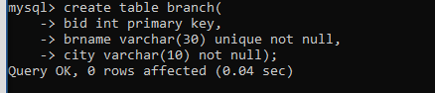
CUSTOMER (CNO INTEGER, CNAME CHAR (20), CADDR CHAR (35), CITY CHAR(20))
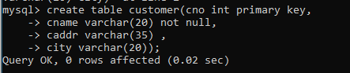
LOAN_APPLICATION (LNO INTEGER, LAMTREQUIRED MONEY, LAMTAPPROVED MONEY, L_DATE DATE)
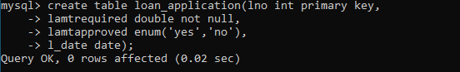
The relationship is as follows:
BRANCH, CUSTOMER, LOAN_APPLICATION are related with ternary relationship. TERNARY (BID INTEGER, CNO INTEGER, LNO INTEGER).
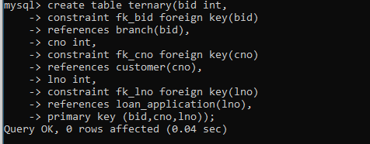
Solve the Queries
- Find the names of the customers for the “Aundh” branch.
- List the names of the customers who have received loan less than their requirement.
- Find the maximum loan amount approved.
- Find out the total loan amount sanctioned by “Deccan “branch.
- Count the number of loan applications received by “M.G.ROAD” branch.
- List the names of the customer along with the branch names who have applied for loan in the month of September.

mysql> create table branch(
-> bid int primary key,
-> brname varchar(30) unique not null,
-> city varchar(10) not null);
Query OK, 0 rows affected (0.04 sec)

> create table customer(cno int primary key,
-> cname varchar(20) not null,
-> caddr varchar(35) ,
-> city varchar(20));
Query OK, 0 rows affected (0.02 sec)

> create table loan_application(lno int primary key,
-> lamtrequired double not null,
-> lamtapproved enum('yes','no'),
-> l_date date);

> create table ternary(bid int,
-> constraint fk_bid foreign key(bid)
-> references branch(bid),
-> cno int,
-> constraint fk_cno foreign key(cno)
-> references customer(cno),
-> lno int,
-> constraint fk_lno foreign key(lno)
-> references loan_application(lno),
-> primary key (bid,cno,lno));

